- Create a Spark application and initialize SparkSession ?
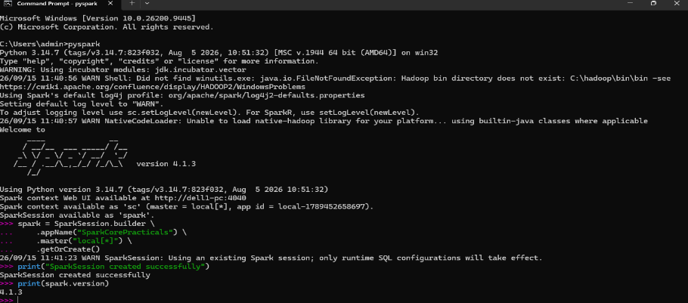
- Create an RDD using parallelize() Method?
- Create an RDD by reading data from a text file ?
- Perform The Map() transformation on an rdd ?
- Perform The Filter() transformation on an rdd ?

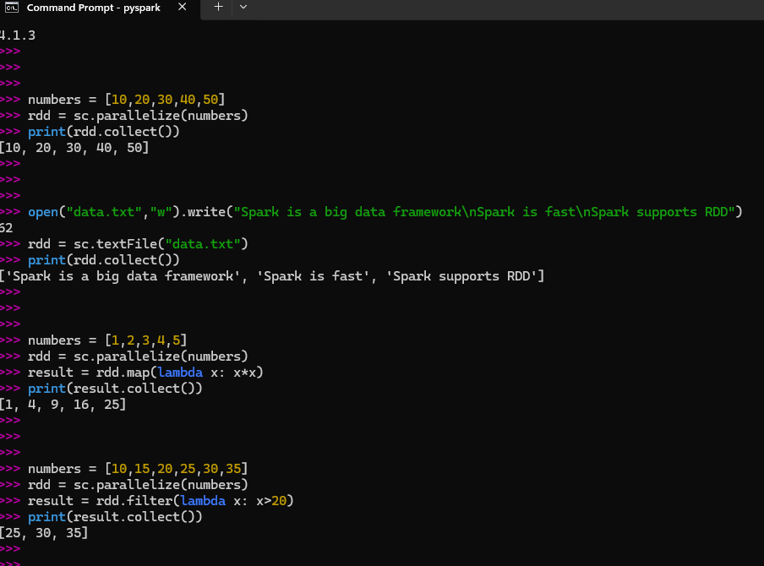

- Perform The Filter() transformation on an rdd ?

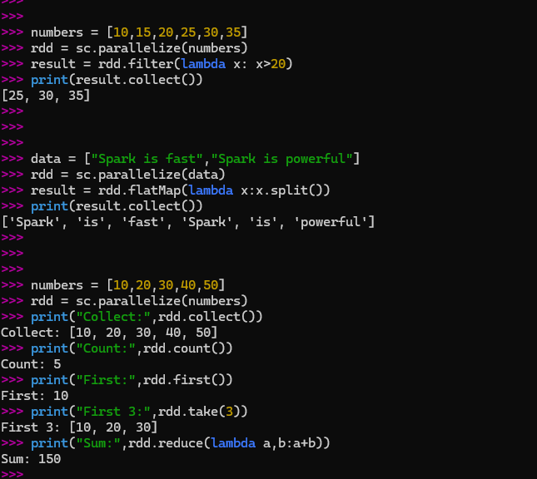
- Write A program to perform a Word count ?

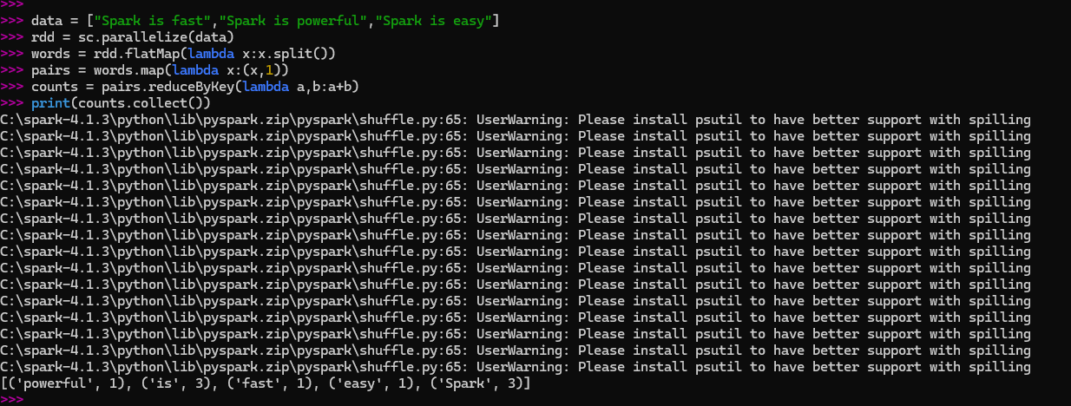

- Create a RDD of Numbers and Perform a Mathematical Operations ?
- Perform Student Marks analysis using spark RDD ?
- Perform Employee Marks analysis using spark RDD ?

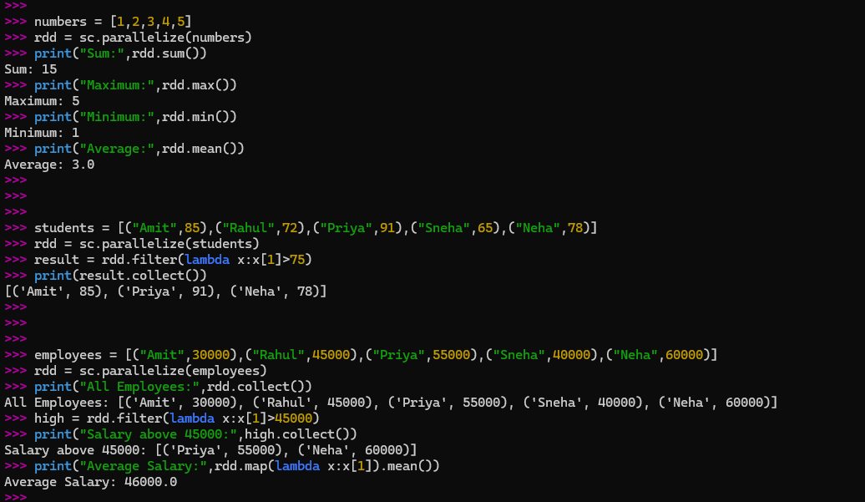

- Create and Perform Operations on a Pair Rdd ?
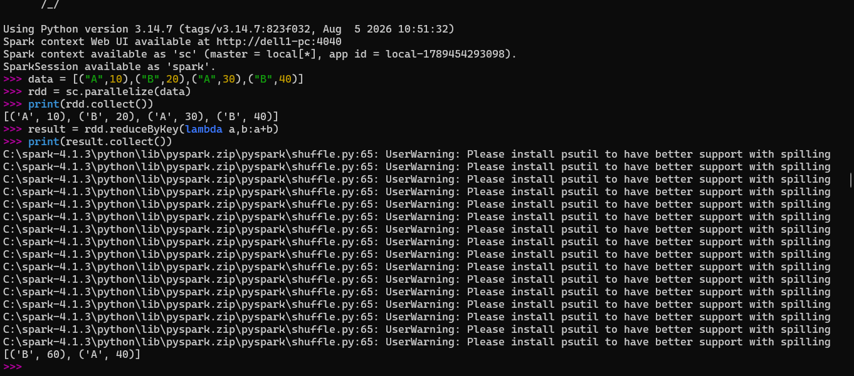
- Calculate Product-wise Total Sales using Spark RDD ?

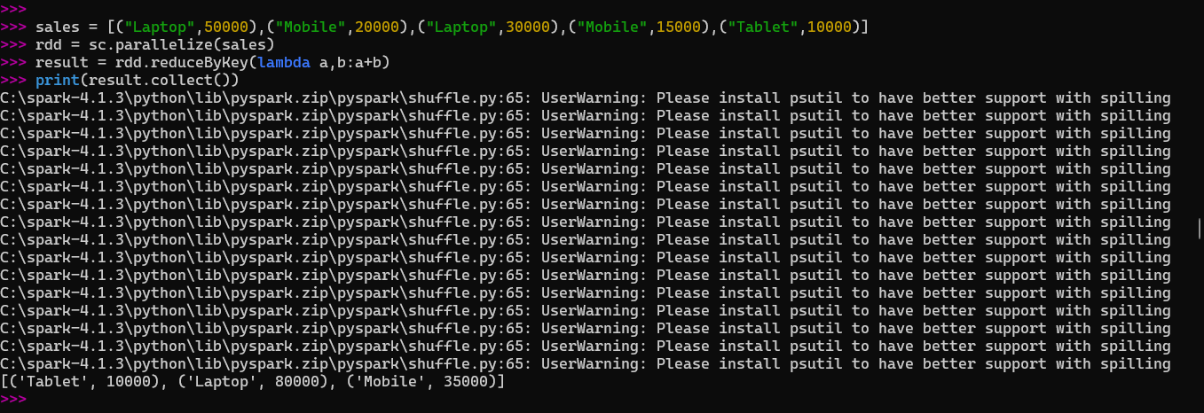

- Perform a reduceByKey() operation on a pair RDD ?

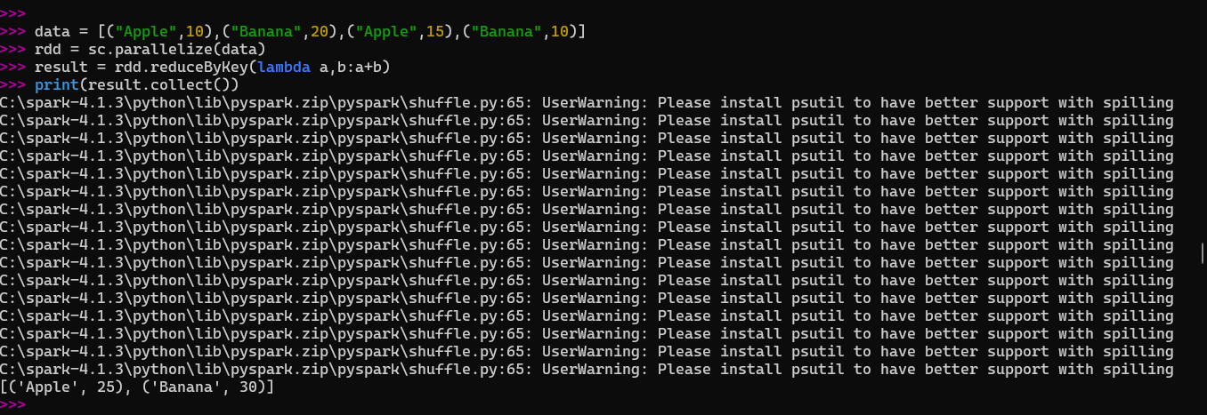

- Perform a groupByKey() operation on a pair RDD ?
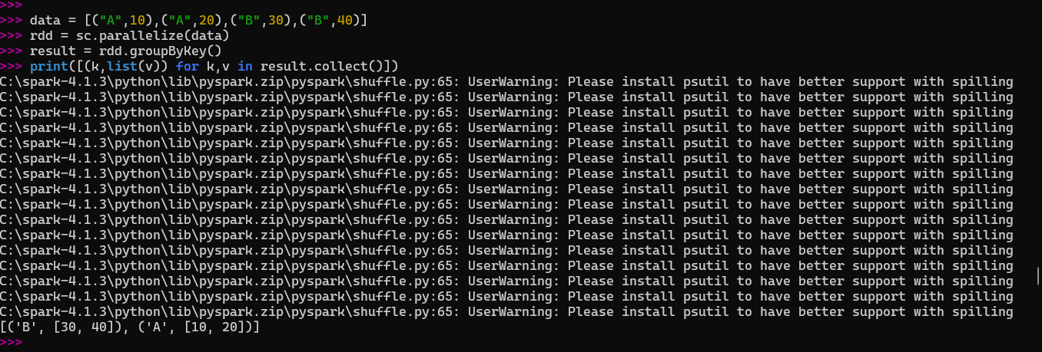
- Perform join operators on Two pair RDD ?

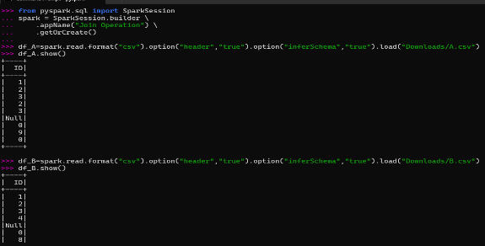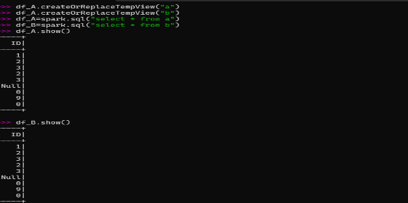
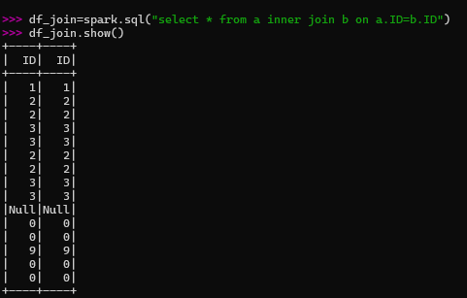

- Perform left outer join ,Right Outer Join and Full outer Join Operations ?

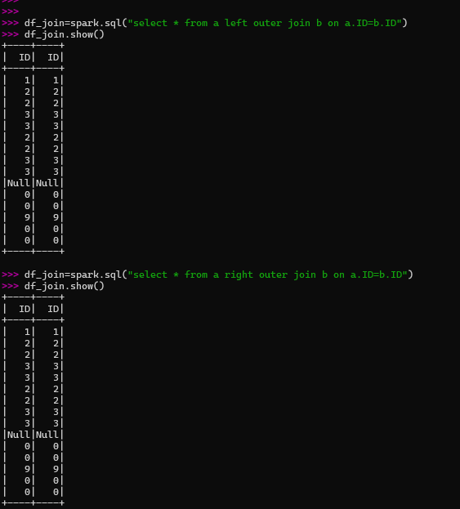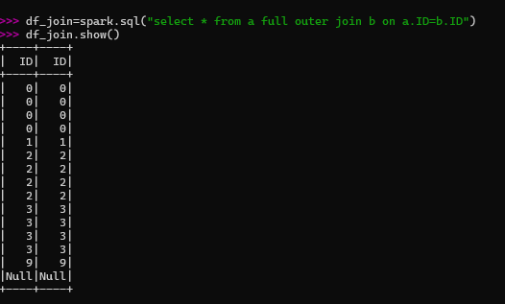
- Demonstarte RDD partitioning using spark ?
- Demonstrate the use of repartition() and coalesce() operations?
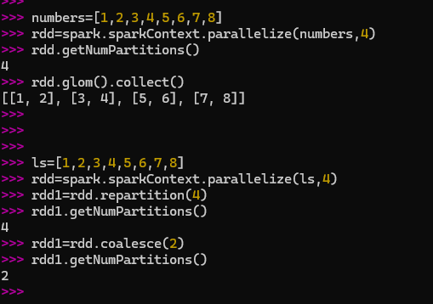

- Demonstrate the use of cache() and persist() in spark ?
